**Tugas4**

**(Membuat Database)**



**Disusun Oleh :**

Arief Nauvan Ramadha

Junior Web Developer A

**PELATIHAN VSGA**

**JUNIOR WEB DEVELOPER**

**DIGITAL TALENT SCHOLARSHIP**

**2021**

1. Membuat database dengan nama db_ptxyz

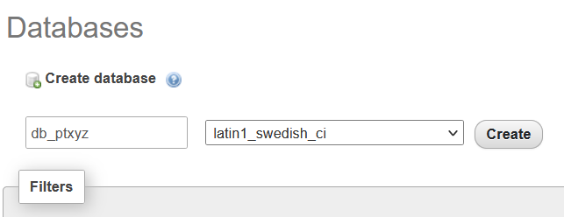

1. Lalu membuat source code php, apakah sudah terkoneksi dengan localhost db_ptxyz

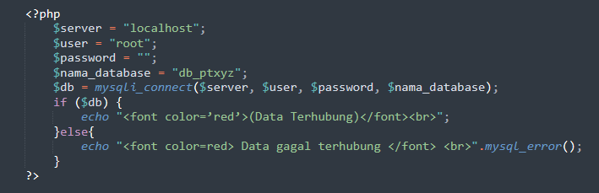

|  |
| --- |
| **<?php**  **$server = "localhost";**  **$user = "root";**  **$password = "";**  **$nama_database = "db_ptxyz";**  **$db = mysqli_connect($server, $user, $password, $nama_database);**  **echo "berhasil terkoneksi..... ";**  **if( !$db ){**  **die("Gagal terhubung dengan database: " . mysqli_connect_error());**  **}**  **?>** |



1. Membuat halaman utama atau halaman home menggunakan php

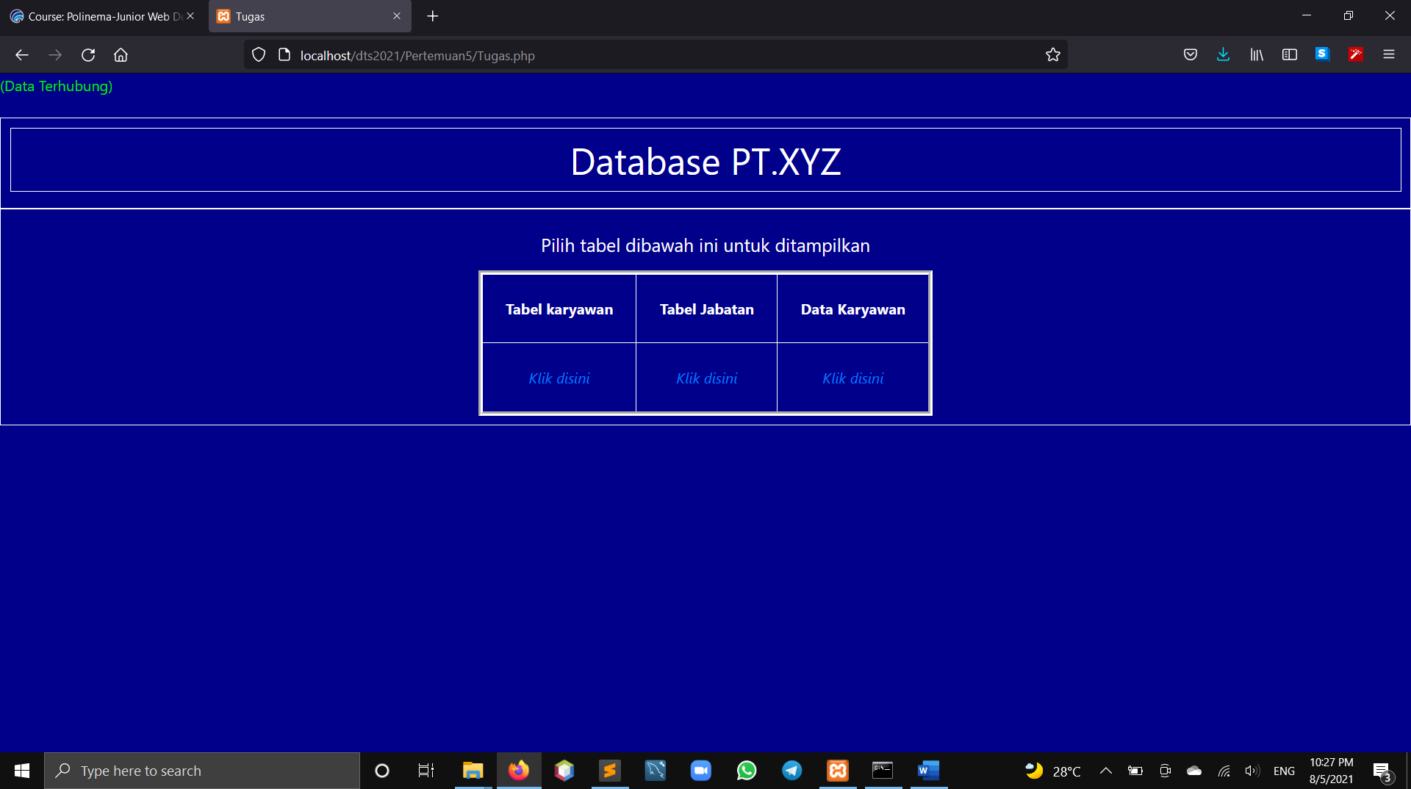

|  |
| --- |
| <!DOCTYPE html>  <html>  <head>  <meta charset="utf-8">  <title>Tugas</title>  <link rel="stylesheet" type="text/css" href="css/bootstrap.css">  <script type="text/javascript" src="js/jquery.js"></script>  <script type="text/javascript" src="js/bootstrap.js"></script>  <style type="text/css">  div{  /*background: darkblue;*/  text-align: center;  border: 1px solid #fff;  padding: 10px;  color: #fff;  }  .konten{  height: 300px;  }  .sidebar{  height: 300px;  }  </style>  </head>  <body style="background: darkblue ;">  <?php  $server = "localhost";  $user = "root";  $password = "";  $nama_database = "db_ptxyz";  $db = mysqli_connect($server, $user, $password, $nama_database);  if ($db) {  echo "<font color=’red’>(Data Terhubung)</font><br>";  }else{  echo "<font color=red> Data gagal terhubung </font> <br>".mysql_error();  }  ?>  <br>  <div>  <h1>  <center>  <div class="col-md-12 col-xs-12">  Database PT.XYZ  </div>  </center>  </h1>  </div>  <div class="col-md-12 col-xs-12">  <p>  <h5>  Pilih tabel dibawah ini untuk ditampilkan  </h5>  </p>  <center>  <table border="5" cellspacing="5" cellpadding="25">  <thead>  <tr>  <th>Tabel karyawan</th>  <th>Tabel Jabatan</th>  <th>Data Karyawan</th>  </tr>  </thead>  <tbody>  <tr>  <td>  <center>  <a href="TabelKaryawan.php">  <em>Klik disini</em>  </a>  </center>  </td>  <td>  <center>  <a href="TabelJabatan.php">  <em>Klik disini</em>  </a>  </center>  </td>  <td>  <center>  <a href="DataKaryawan.php">  <em>Klik disini</em>  </a>  </center>  </td>  </tr>  </tbody>  </table>  </center>  </div>    </body>  </html> |

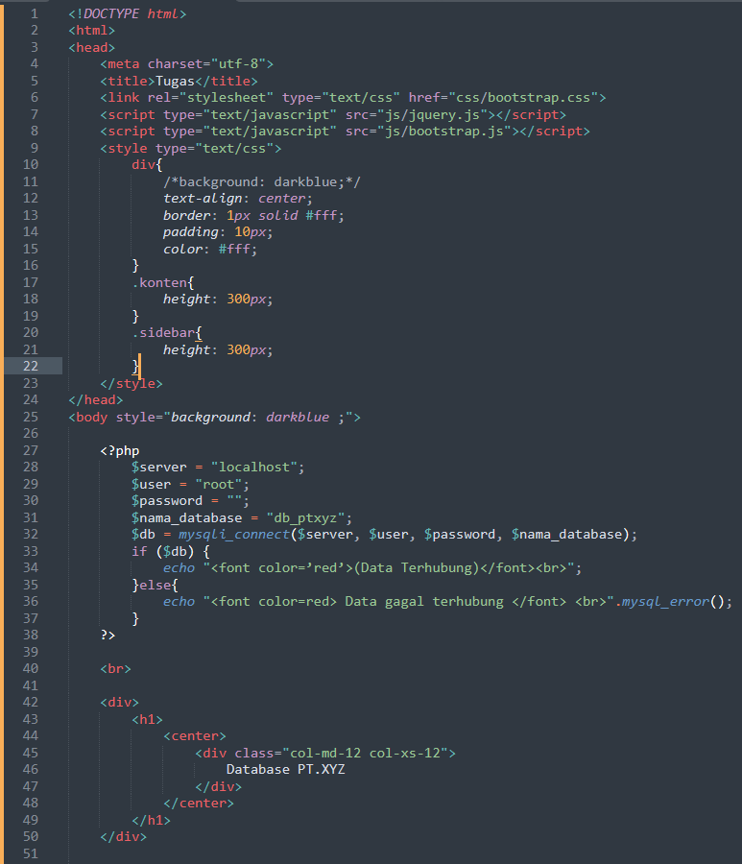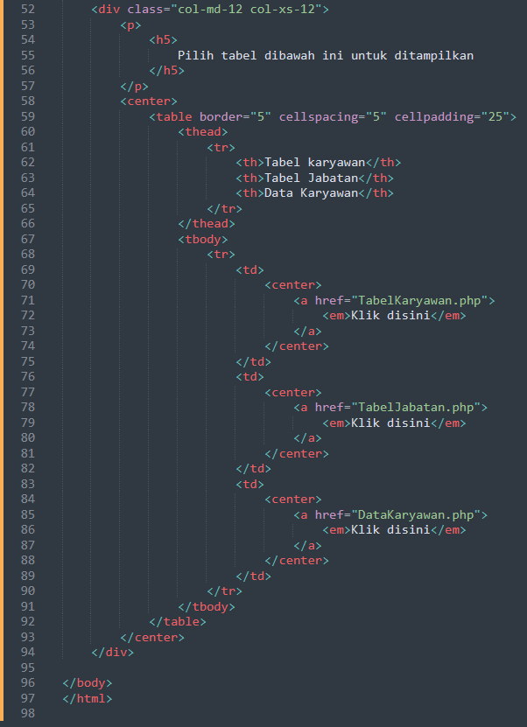

1. Membuat table karyawan dan menampilkan tabel dengan kolom id, nama_karyawan, alamat, jenis_kelamin, dan telp

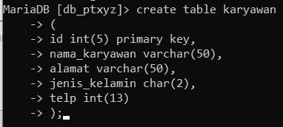

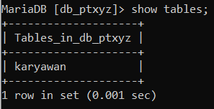

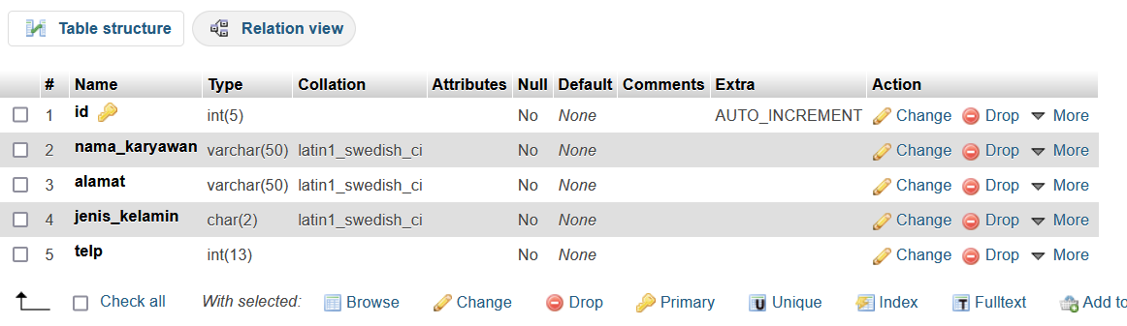

\***Dengan menggunakan PHP**

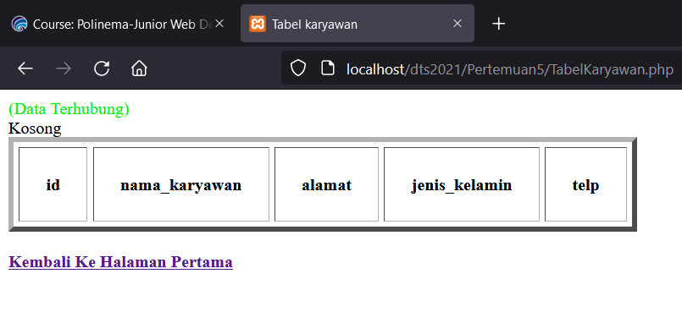

|  |
| --- |
| <!DOCTYPE html>  <html>  <head>  <meta charset="utf-8">  <title>Tabel karyawan</title>  </head>  <body>  <table border="5" cellspacing="5" cellpadding="25">  <thead>  <tr>  <th>id</th>  <th>nama_karyawan</th>  <th>alamat</th>  <th>jenis_kelamin</th>  <th>telp</th>  </tr>  </thead>  <?php  $server = "localhost";  $user = "root";  $password = "";  $nama_database = "db_ptxyz";  $connect = mysqli_connect($server, $user, $password, $nama_database);  if ($connect) {  echo "<font color=’red’>(Data Terhubung)</font><br>";  }else{  echo "<font color=red> Data gagal terhubung </font> <br>".mysql_error();  }  $query = "select * from karyawan";  $result = mysqli_query($connect, $query);  if (mysqli_num_rows($result) < 0) {  while ($row = mysqli_fetch_array($result)) {  ?>  <tbody>  <tr>  <td>  <?php  echo $row['id'];  ?>  </td>  <td>  <?php  echo $row['nama_karyawan'];  ?>  </td>  <td>  <?php  echo $row['alamat'];  ?>  </td>  <td>  <?php  echo $row['jenis_kelamin'];  ?>  </td>  <td>  <?php  echo $row['telp'];  ?>  </td>  <?php  }  }else{  echo "Kosong";  }  ?>  </tr>  </tbody>  </table>  <br>  <a href="Tugas.php">  <strong>Kembali Ke Halaman Pertama</strong>  </a>    <br>  </body>  </html> |

**\*Menggunakan php**

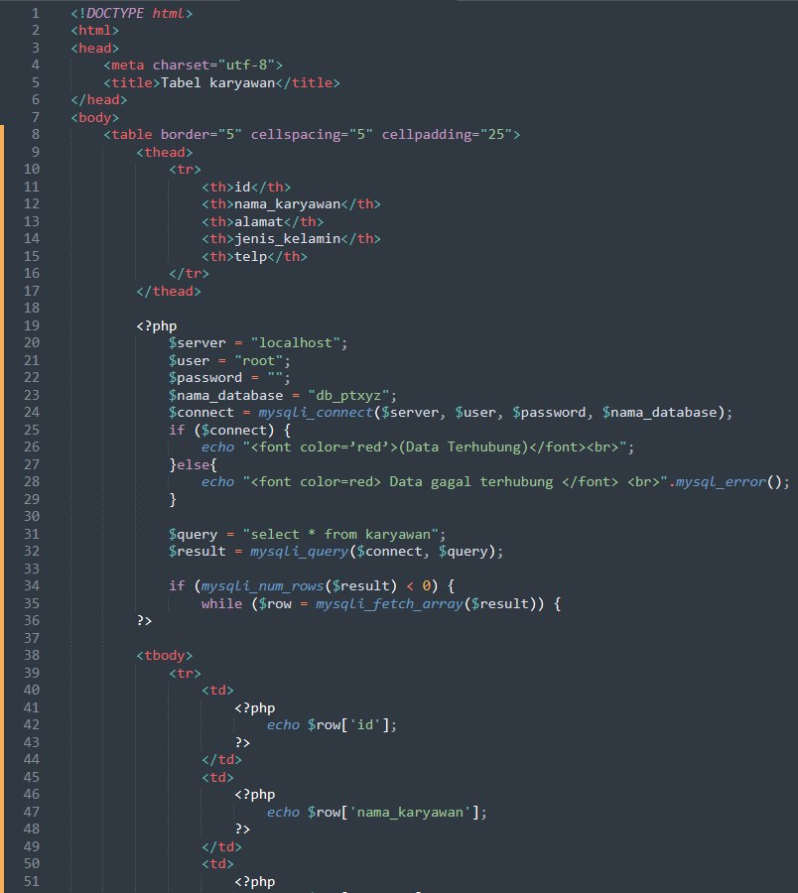

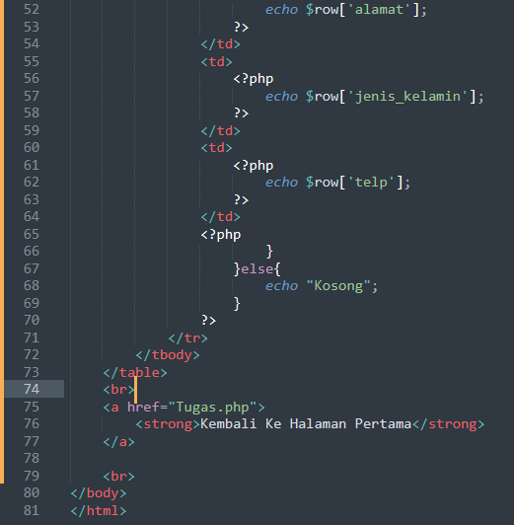

1. Memasukkan data didalam table karyawan

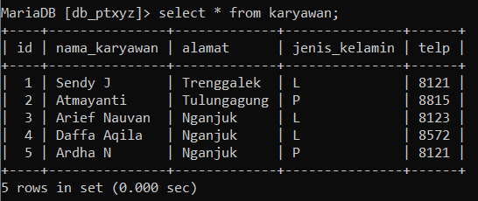

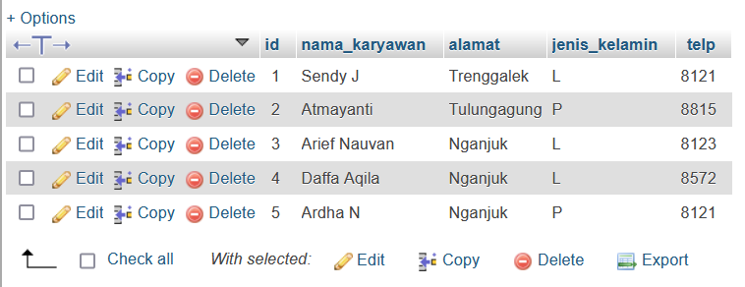

**\*Menggunakan php**

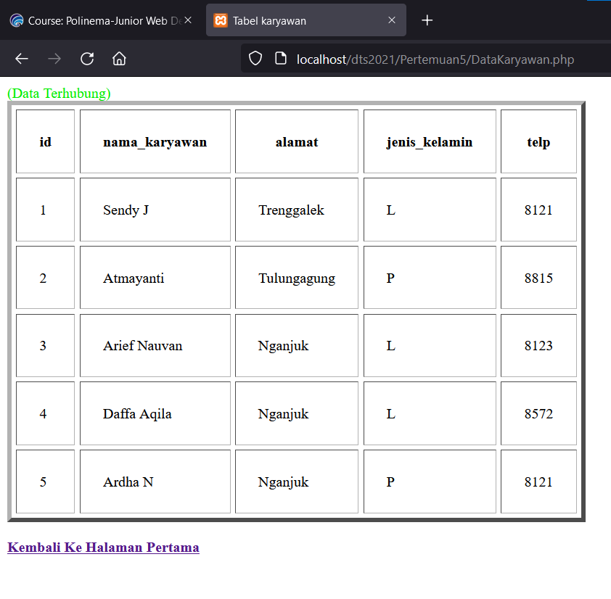

|  |
| --- |
| <!DOCTYPE html>  <html>  <head>  <meta charset="utf-8">  <title>Tabel karyawan</title>  </head>  <body>  <table border="5" cellspacing="5" cellpadding="25">  <thead>  <tr>  <th>id</th>  <th>nama_karyawan</th>  <th>alamat</th>  <th>jenis_kelamin</th>  <th>telp</th>  </tr>  </thead>  <?php  $server = "localhost";  $user = "root";  $password = "";  $nama_database = "db_ptxyz";  $connect = mysqli_connect($server, $user, $password, $nama_database);  if ($connect) {  echo "<font color=’red’>(Data Terhubung)</font><br>";  }else{  echo "<font color=red> Data gagal terhubung </font> <br>".mysql_error();  }  $query = "select * from karyawan";  $result = mysqli_query($connect, $query);  if (mysqli_num_rows($result) > 0) {  while ($row = mysqli_fetch_array($result)) {  ?>  <tbody>  <tr>  <td>  <?php  echo $row['id'];  ?>  </td>  <td>  <?php  echo $row['nama_karyawan'];  ?>  </td>  <td>  <?php  echo $row['alamat'];  ?>  </td>  <td>  <?php  echo $row['jenis_kelamin'];  ?>  </td>  <td>  <?php  echo $row['telp'];  ?>  </td>  <?php  }  }else{  echo "Kosong";  }  ?>  </tr>  </tbody>  </table>  <br>  <a href="Tugas.php">  <strong>Kembali Ke Halaman Pertama</strong>  </a>  </body>  </html> |

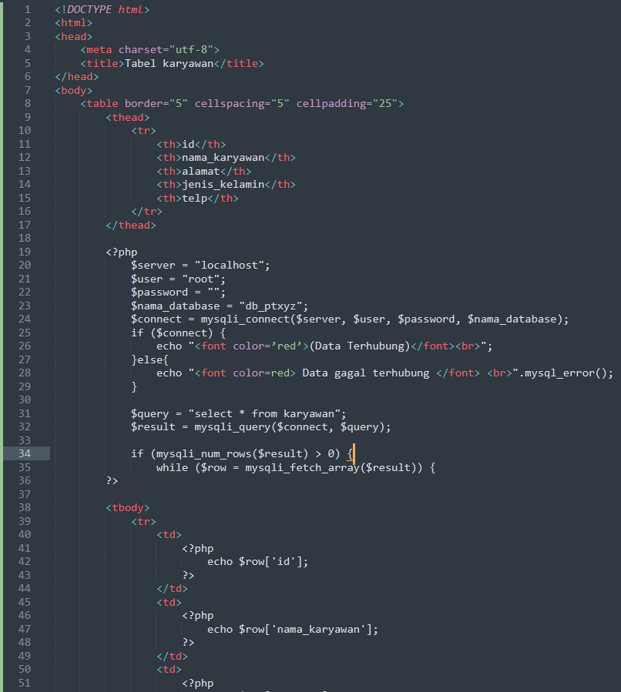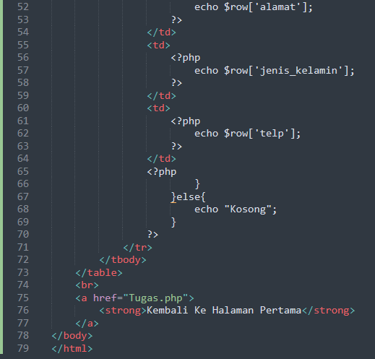

1. Membuat table baru dengan nama table jabatan dengan id, jabatan, dan golongan

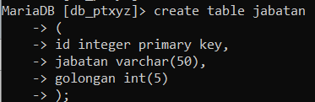

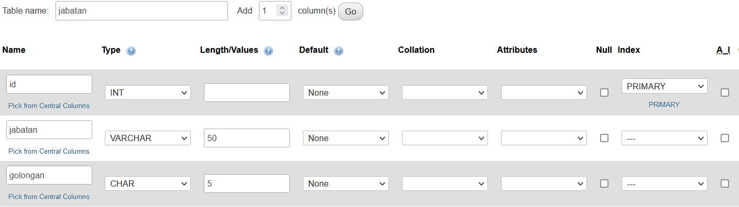

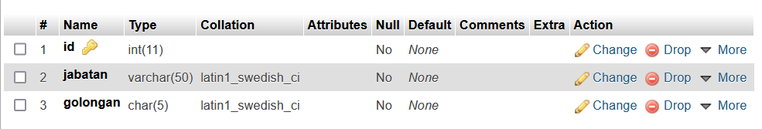

**\*Dengan php**

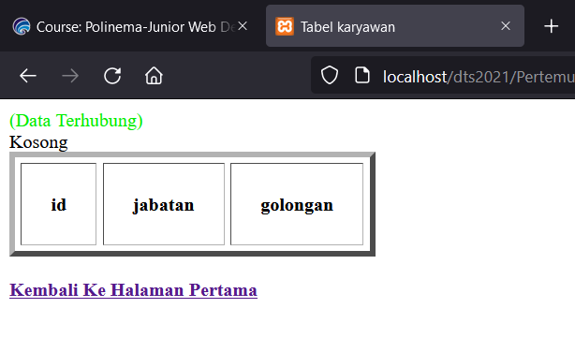

|  |
| --- |
| <!DOCTYPE html>  <html>  <head>  <meta charset="utf-8">  <title>Tabel karyawan</title>  </head>  <body>  <table border="5" cellspacing="5" cellpadding="25">  <thead>  <tr>  <th>id</th>  <th>jabatan</th>  <th>golongan</th>  </tr>  </thead>  <?php  $server = "localhost";  $user = "root";  $password = "";  $nama_database = "db_ptxyz";  $connect = mysqli_connect($server, $user, $password, $nama_database);  if ($connect) {  echo "<font color=’red’>(Data Terhubung)</font><br>";  }else{  echo "<font color=red> Data gagal terhubung </font> <br>".mysql_error();  }  $query = "select * from jabatan";  $result = mysqli_query($connect, $query);  if (mysqli_num_rows($result) < 0) {  while ($row = mysqli_fetch_array($result)) {  ?>  <tbody>  <tr>  <td>  <?php  echo $row['id'];  ?>  </td>  <td>  <?php  echo $row['jabatan'];  ?>  </td>  <td>  <?php  echo $row['golongan'];  ?>  </td>  <?php  }  }else{  echo "Kosong";  }  ?>  </tr>  </tbody>  </table>  <br>  <a href="Tugas.php">  <strong>Kembali Ke Halaman Pertama</strong>  </a>  </body>  </html> |

